**Instance Metadata Finding – SAGAR MENDIRATTA**

There are couple of Approaches to find the AWS EC2 Instance Metadata ( private IP address and other information) about the AWS EC2 instance. Below of are some which I used.

**Approach 1:** **Python Script using Boto3 library** **(Code that I wrote is present in the folder)**

* Below code fetches the Instance ID and instance type using for loop which are tagged with instance type =t2.micro
* Also, below code fetches all the instance details those are running in us-east-1 region

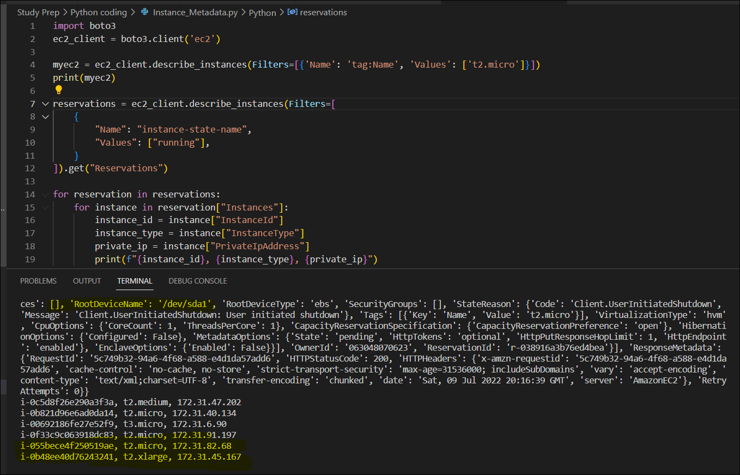

**Approach 2:** Ansible Playbook and a Ansible task **(Playbook code is in the folder)**

* In this approach I used Ansible ad hoc command to run the command to fetch the metadata.
* Also Created Playbook on Ansible host controller and used metadata facts Ansible task to perform fetch the metadata.

**Details of the Activity**

**Instance 1:**

* t2.micro
* Key1
* 44.202.240.141
* ip-172-31-91-197

**Instance2**

* t3.micro
* key2
* 44.203.97.193
* ip-172-31-91-123

Step 1) Logging into **Ubuntu Machine1**

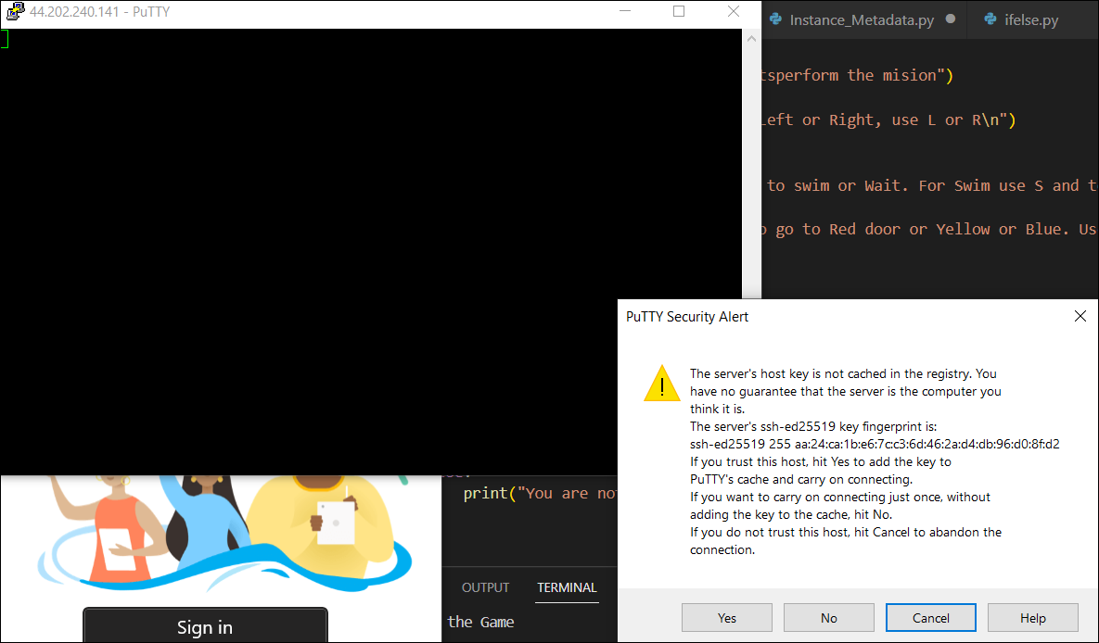

2) From Ubuntu machine trying to connect to second machine but it failed.

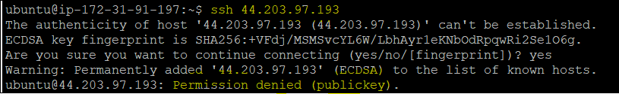

3) generating SSH keys on first machine and adding the public key on second machine

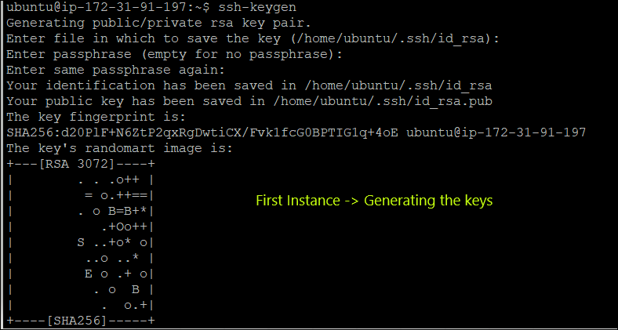



4) Now able to connect or SSH from 1st machine to 2nd Machine.

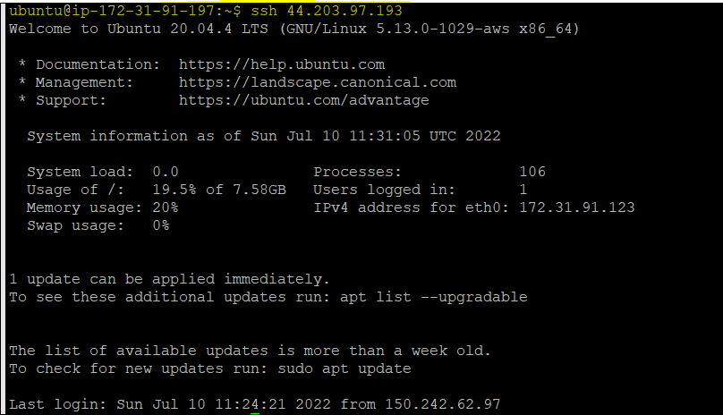

3) Installing Ansible and required softwares such as boto3.

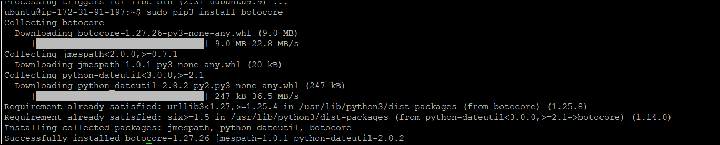

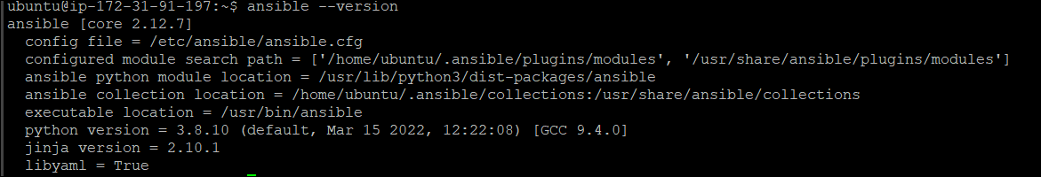

4) Testing the ansible ad hoc command

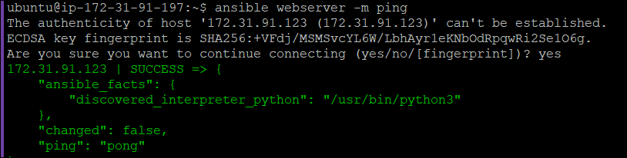

**5) Using Ansible Ad hoc command fetching the Instance Metadata. As you can see the details are retrieved using the curl command.**

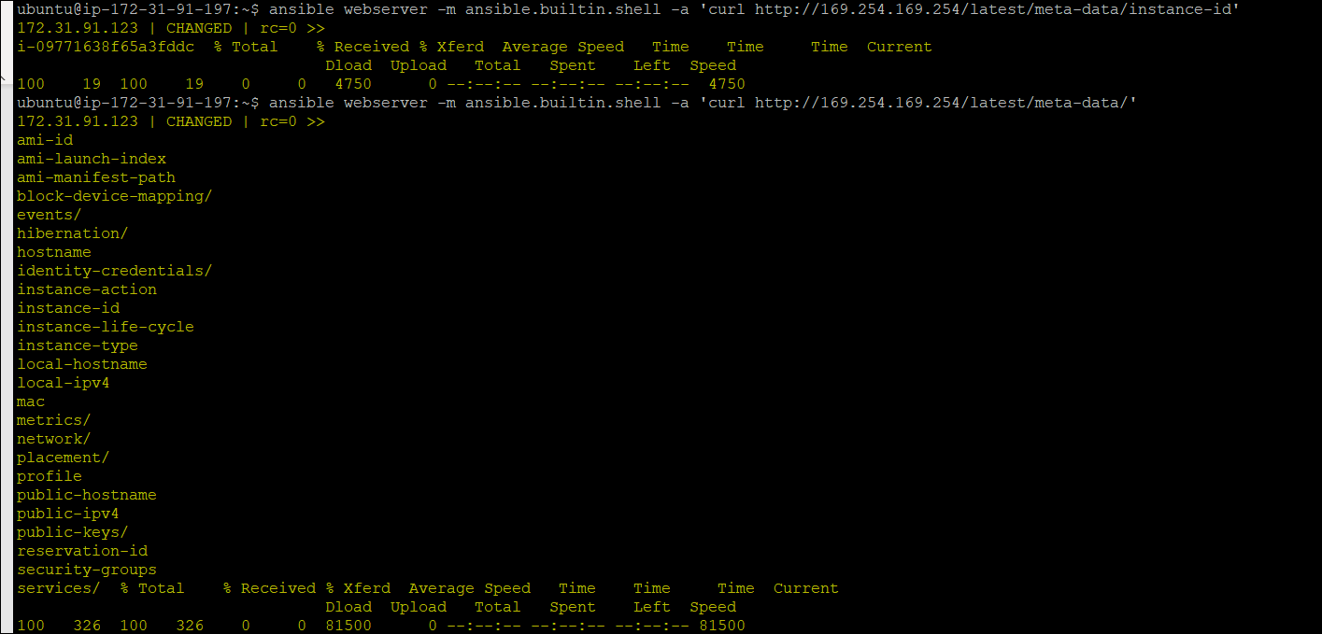

**6) Using Ansible Playbook to fetch the Instance Metadata. Also in the below snapshot, there were 3 tasks such as to get the information of ec2 and metadata.**

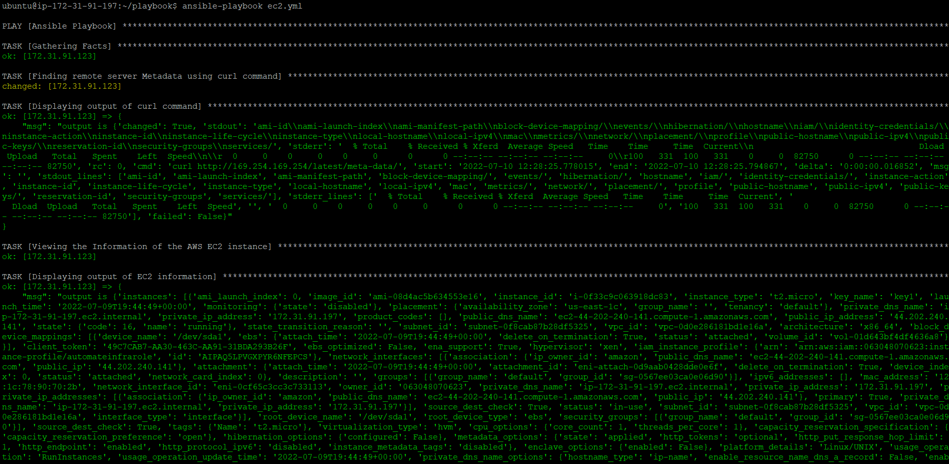

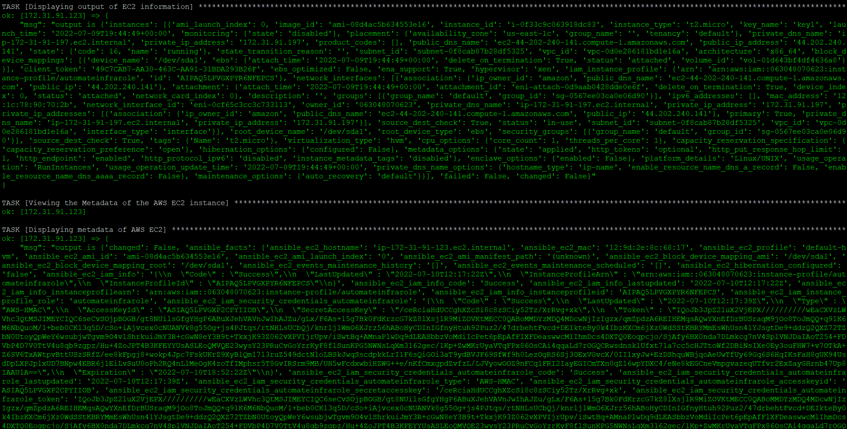

**Approach 3:** Simply By using curl command

*curl http://169.254.169.254/latest/meta-data/instance-id*

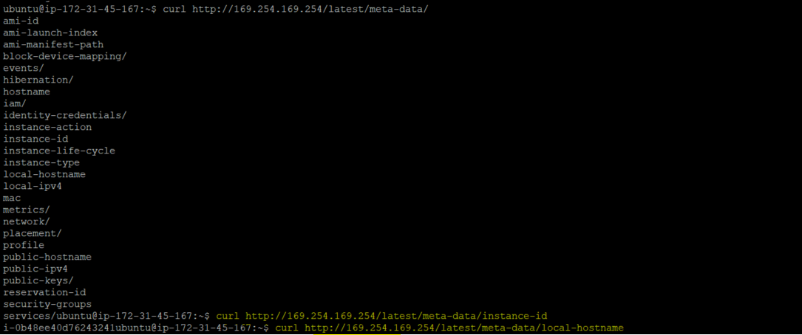

**Approach 4:** Using Terraform provisioner

* By running the command remotely inside the EC2 **instance (Code is present in the folder)**

